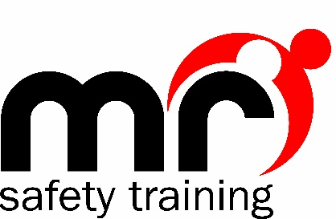

Covid-19 Learner Guidelines

It is imperative that when MR Safety Training (MRST) conducts training courses, everyone concerned is kept safe at all times.
DO NOT come to a training course if you or a member of your household have experienced Covid symptoms (hot to the touch, new constant cough, loss of smell/taste) within the last 14 days. You must self-isolate and seek medical advice.
DO NOT come to a training course if you are awaiting results of a Covid test.

When you come to training:
Please only bring personal items which you need for the time of the course. Excessive personal items increase the risk of infection spread.
You will be asked to wash your hands upon arrival
Antibacterial hand wash will be available in the training venue
Hand sanitizer gel will be available to use throughout the course
Gloves will be available for any practical use
You are strongly encouraged to bring a face mask with you and wear it at all times during the course to reduce the risk of any virus transmission.

For First Aid courses:
Manikins will be sterilised before use and after use, with fresh lungs for each training session
You will have your own training pack and book to use, and these will be sanitised before given to you
Please wash your hands or use sanitising hand gel before and after any practical activity
Each training venue has adequate ventilation to maintain air circulation
All training sessions will be adapted to fully limit personal contact with others

The Training Room:
It is important to maintain a distance of 2 metres from other people during the course, so when entering the room make sure you walk at a safe distance from others to your seat, and do the same when exiting the room.

Refreshments:
MRST will not be providing refreshments on any courses during the Covid pandemic. If you wish to have refreshments, please bring your own and dispose of waste in the bins provided.

Failure to follow any of the above guidelines will result in you being asked to leave the course immediately.
If you develop any of the Covid symptoms during any MRST training session, you will be asked to leave immediately, self isolate and seek medical guidance.
If you develop any Covid symptoms within 2 days following any MRST training session, you are required to inform MRST office team, as we need to inform others using a Track & Trace system.

